***DEV EXP - 01***

***Program code***

***(Python (Anaconda Recommended))***

import matplotlib.pyplot as plt

x = [1, 2, 3, 4]

y = [10, 20, 25, 30]

plt.plot(x, y)

plt.title("Simple Line Chart")

plt.xlabel("X-axis")

plt.ylabel("Y-axis")

plt.show()

***Output :***

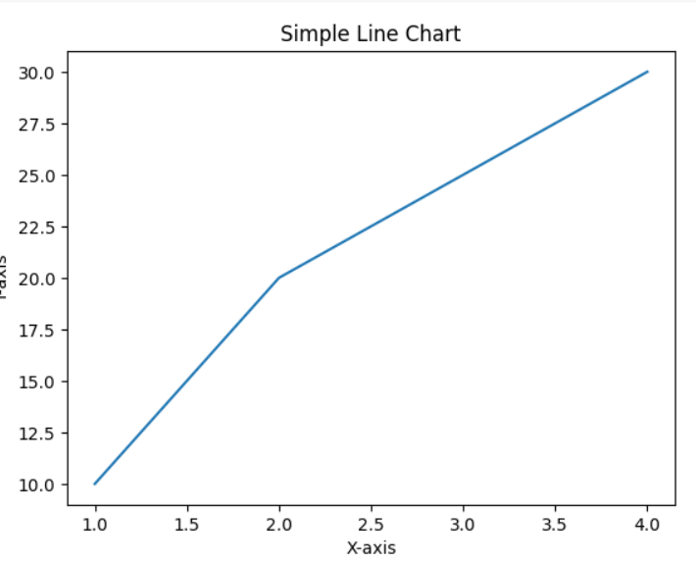

***Program code:***

***(. R and RStudio)***

*x <- c(1, 2, 3, 4)*

*y <- c(10, 20, 25, 30)*

*plot(x, y, type="o", col="blue", main="Simple Line Plot", xlab="X-axis", ylab="Y-axis")*

***output:***

***Y-axis***

***^***

***|***

***| ●***

***| / \***

***| / ●***

***| / \***

***| ● \***

***| / \***

***| ●-----------●-------------> X-axis***

***1 2 3 4***

***Program code***

***(Microsoft Power BI Desktop)***

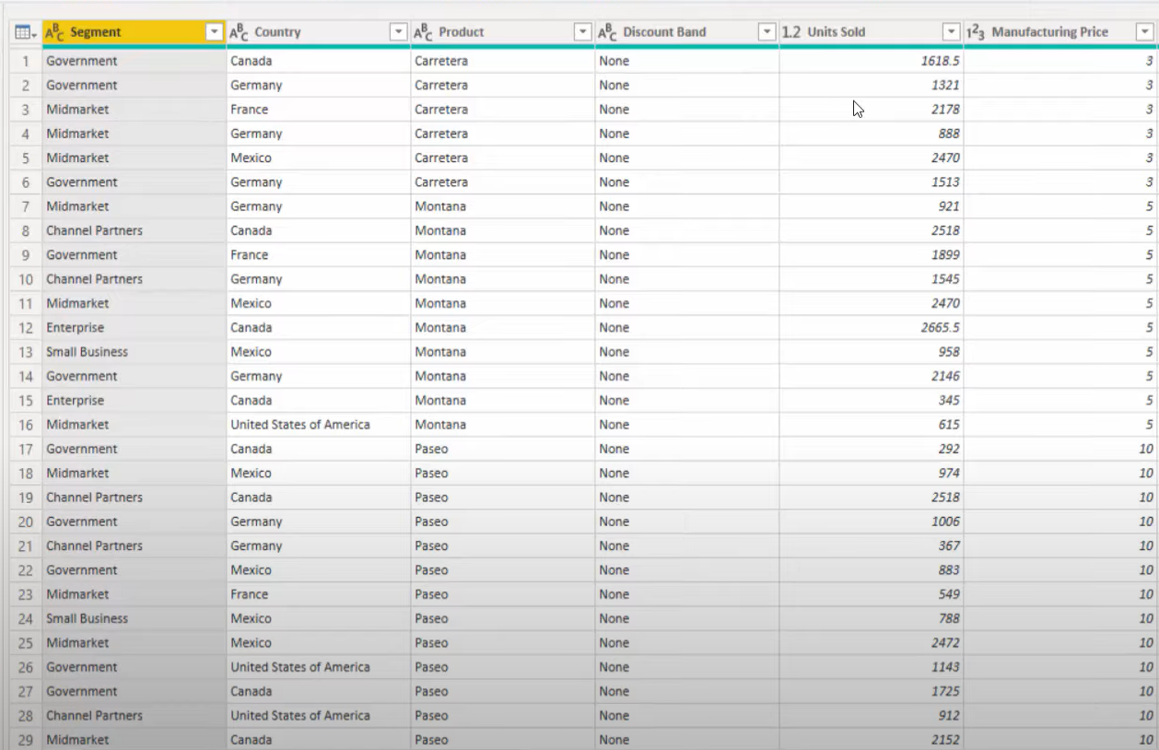

***Output:***



***Program code***

***(Tableau Public)***

***Dataset***



